Assignment for **Oracle E- Business Suite General Ledger**

Date: 18th Nov-2024

1 and 2

1. Create Your Own user ID from System Administrator Responsibility.  
 Assign the following responsibilities to your Oracle User ID

* **Vision Operation General Ledger.**
* **Vision Operation Inventory**.
* **Vision Operation Procurement**

2. For your user ID password expiration day should be 60 days

Path

Login to Oracle EBS > Switch to System Administrator Responsibility 

Security > User > Define

User Creation

* Enter the User Name
* Enter the Password > Push TAB
  + Type the password again > Push TAB
* Enter a description
* (2) In the “To” field under “Effective Dates” set the date to be 60 days from today (17-JAN-2025) to set when access will be automatically revoked

Assign User Responsibilities

* Click into one of the fields under “Responsibility”
  + If all the fields are full, click into a field and then click “New” 
* Query the field using one of the following methods
  + You can use a wildcard search using % and then hit TAB
  + Click the LAV button  and perform an advanced search for the responsibility
* The data associated with the responsibility should auto-fill

Repeat the above steps for the following responsibilities:

* General Ledger, Vision Operations (USA)
* Inventory, Vision Operations (USA)
* Purchasing, Vision Operations (USA)

Click “Save” 

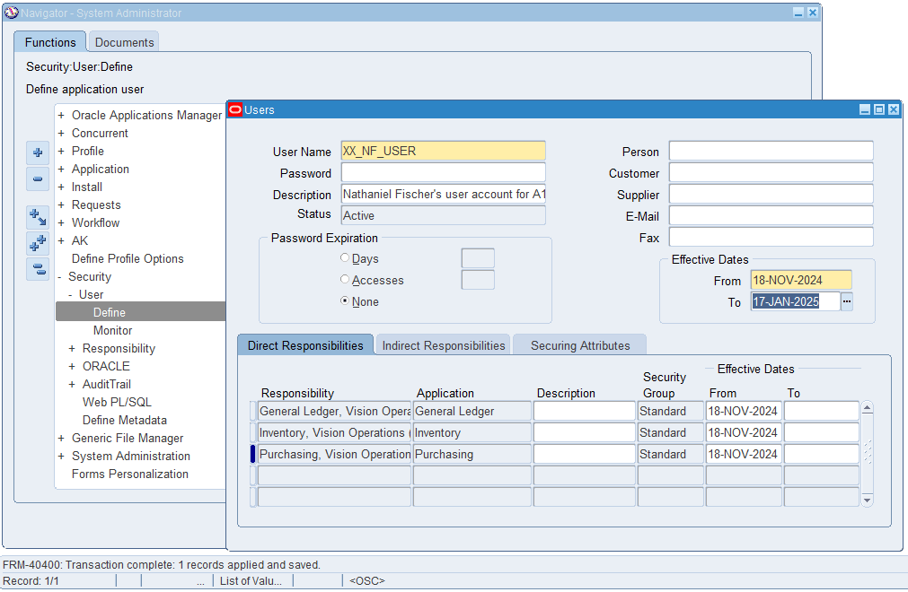

3. In **Vision Operation General Ledger** responsibility.

Form Accounting Setup Manager> Find the **Vision Operation [Primary Ledger]**

In this Ledger finds the **4C** Component, mentions the 4C name & take the screen shot as Evidence.

1. Find the Respective Calendar **Vision Operation [Primary Ledger].**

Path

Login to Oracle EBS > Switch to General Ledger, Vision Operations (USA) Responsibility 

Setup > Financials > Accounting Setup Manager > Accounting Setups

This will launch an HTML page

Access the “4 C’s” Information for the Primary Ledger

* Search for “Vision Operations”
* Click the pencil icon  under the “Update Accounting Options” field

* On the next page, click the “Vision Operations (USA)” under the “Setup Step” column in the “Primary Ledger: Vision Operations (USA)” section
  + A screenshot of a computer

    Description automatically generated
* The “4 C’s” information will be displayed on the next page

Currency: **USD**

Chart of Accounts (CoA): **Operations Accounting Flex**

Calendar: **Accounting**

Convention: **Standard Accrual**

Find the Associated Calendar in the EBS System

Login to Oracle EBS > Switch to General Ledger, Vision Operations (USA) Responsibility 

Setup > Financials > Calendars > Accounting

* Push F11 to query the fields
* Type “Accounting” in the “Calendar” field
* Push CTRL + F11 to run the query

4 and 12

4. Find all the **Account Code Combinations.**

12. Find how many types of accounts in Oracle GL [Account Code Combination]?

Path

Login to Oracle EBS > Switch to General Ledger, Vision Operations (USA) Responsibility 

Setup > Accounts > Combinations

(4) In the window that pops up push CTRL + F11 to query all account combinations in the system

(12) To Query a Specific Type

* When the window pops up, press F11
* Enter the type you are looking for under the “Type” field
  + A screenshot of a computer

    Description automatically generated
* Press CRTL + F11 to query all records of that type
  + A screenshot of a computer

    Description automatically generated

There are 5 different account types:

1. Asset
2. Liability
3. Owner’s Equity
4. Revenue
5. Expense

5, 6, and 7

5. Find all the Journals [**SOURCE: Payables].**

6. In Journal Header from record History find the respective **Data base Table**

**name.**

7. Find the one Manual [Source] & one Payable [Source]. Path

Login to Oracle EBS > Switch to General Ledger, Vision Operations (USA) Responsibility 

Journals > Enter

(5) Find the Relevant Journals

* Enter “Payables” in the “Source” field
* Click “Find”

A list of all journals from the “Payables” source will be brought up

(7) Find the details for a Journal from the “Payables” Source

* Click on a journal record
* Click “Review Journal”

(6) Find the Journal Header Table

* Click on a field in the Journal Header
  + A screenshot of a computer

    Description automatically generated
* Click “Help”
  + A computer screen shot of a yellow box with black text

    Description automatically generated
* Click “Record History”
  + A screenshot of a computer

    Description automatically generated
* The record information will be displayed, including the table name
  + A screenshot of a record

    Description automatically generated
  + This is a view, the underlying table would be “GL_JE_HEADERS”

(7) Find the details for a Journal from the “Manual” Source

* Follow the steps at the top, but this time enter “Manual” in the “Source” field
* Click on a journal record
* Click “Review Journal”

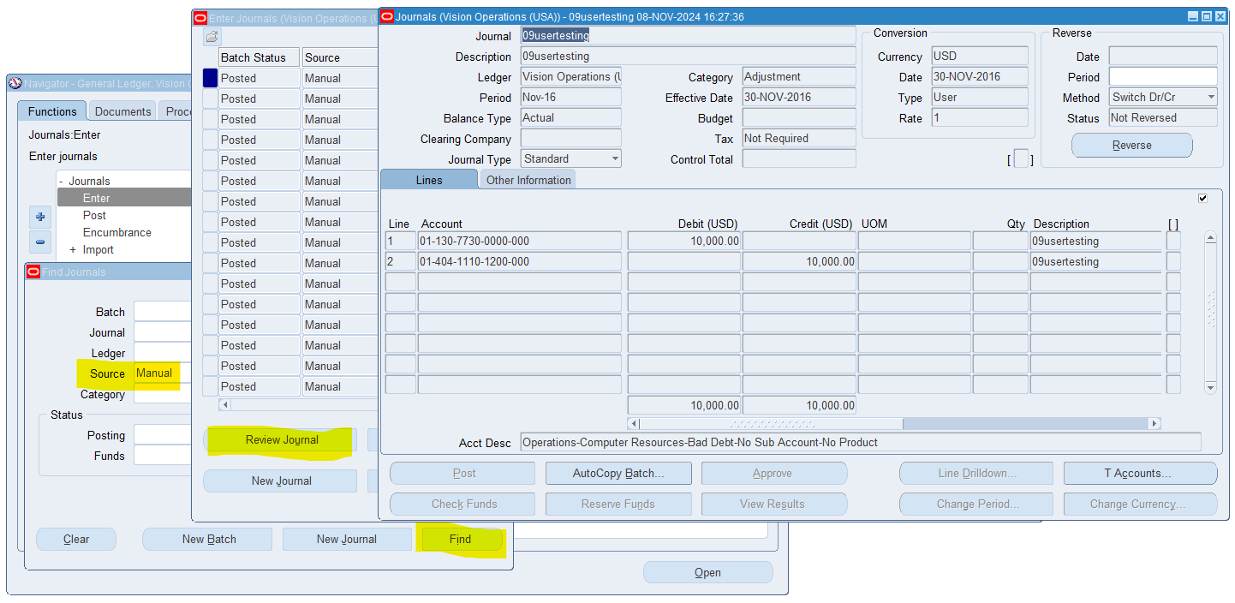

8. How can you review posted journal entries in Oracle GL? Steps & screen shots

Path

Login to Oracle EBS > Switch to General Ledger, Vision Operations (USA) Responsibility 

Journals > Enter

Find the Relevant Journals

* Enter “Posted” in the “Posting” field
  + A screenshot of a computer

    Description automatically generated
* Click “Find”
* Click on a journal record
* Click “Review Journal”
  + A screenshot of a computer

    Description automatically generated
* The journal line transactions will be displayed

9 and 13

9. Find the **Chart of Accounts [COA]** Structure in General Ledger.

13. Check & show the Structure of Chart of Account segment structure.

Path

Login to Oracle EBS > Switch to General Ledger, Vision Operations (USA) Responsibility 

Setup > Financials > Flexfields > Key > Segments

* Press CTRL + F11 to query all Chart of Account Combinations
* Click on a Chart of Accounts you want to view the structure of
* Click on “Segments” to view the structure

10. How are you going to run one **Concurrent Request** from General Ledger (Navigation).

Path

Login to Oracle EBS > Switch to General Ledger, Vision Operations (USA) Responsibility 

* Click “View”
  + A screenshot of a computer

    Description automatically generated
* Click “Requests”
  + A screenshot of a computer

    Description automatically generated
* Click “Submit a new Request”
  + A screenshot of a computer

    Description automatically generated
* Enter the name of the request
  + You can perform a wildcard search with % and then hit TAB
  + You can perform an advanced search with the LAV button 
* Enter the parameters if any
  + A screenshot of a computer

    Description automatically generated
* Click “Submit”
* A request ID will be generated
  + A screenshot of a computer

    Description automatically generated
* Click “No”
* Click “Find” to list all of the recent requests
  + You can also search for the specific request ID
* You will see the status of your request
  + A screenshot of a computer

    Description automatically generated

11. In One Ledger Set what are all components common in all the Ledger?

Path

Login to Oracle EBS > Switch to General Ledger, Vision Operations (USA) Responsibility 

Setup > Financials > Ledger Sets

Every Ledger Set has the same Chart of Accounts and Calendar for every ledger in the set